* When using the startgazer package you need to use the option results='asis' in the knitr options of your chunk of code. That way you results will print nicely in the html document.
* The stargazer package and function allows you to make tables in differnet types, such as, LaTex, text, or html. You need to specify the type in the type argument of the stargazer table, depending on the type you need to change the knirt options to see results looking neat when knitting.

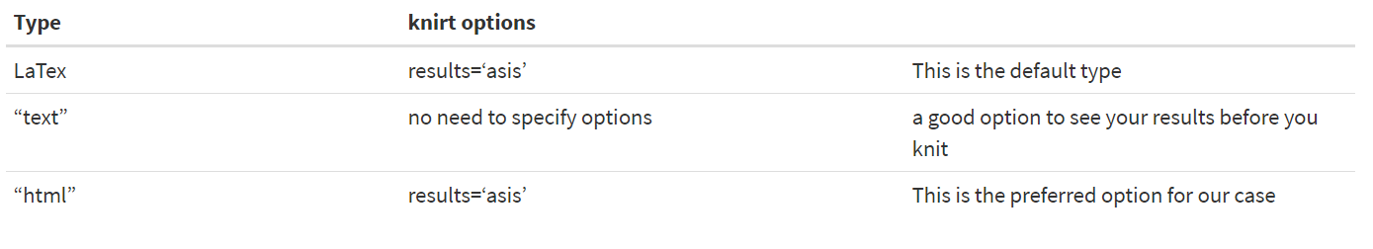

# Use the option results=`asis` in your chunk of code so your results show in your html document

# Michigan department of education dataset

meap93set <- meap93 %>% select(salary, benefits, enroll, droprate)

# PAY ATTENTION TO THE TYPE

# Default option is latex

**stargazer**(meap93set, type = "html", digits = 1)

Output:

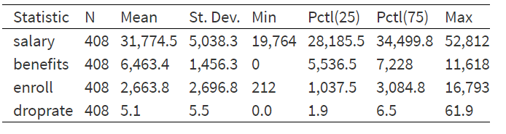

* Choosing the statistics; **remember** when the output type is “text”, you have to delete results = ‘asis’ or else knitting the document will not yield desired table

stargazer(meap93set, **type = "text"**, **summary.stat =** c("n", "p75", "sd"))

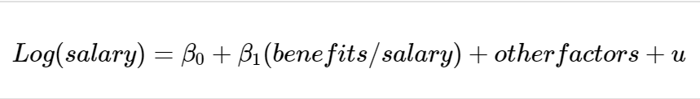

data(meap93, package = "wooldridge")

# define new variable within data frame

meap93$b_s <- meap93$benefits/meap93$salary

# Estimate three different models and store them in R objects.

model1 <- lm(log(salary) ~ b_s, data = meap93)

model2 <- lm(log(salary) ~ b_s + log(enroll) + log(staff), data = meap93)

model3 <- lm(log(salary) ~ b_s + log(enroll) + log(staff) +

droprate + gradrate, data = meap93)

# Display table of results

**stargazer**(**list**(model1, model2, model3), type = "text")

* #Using QJE publication style

stargazer(list(model1, model2, model3), type = "html",

keep.stat = c("n", "rsq"), **style = "qje"**)

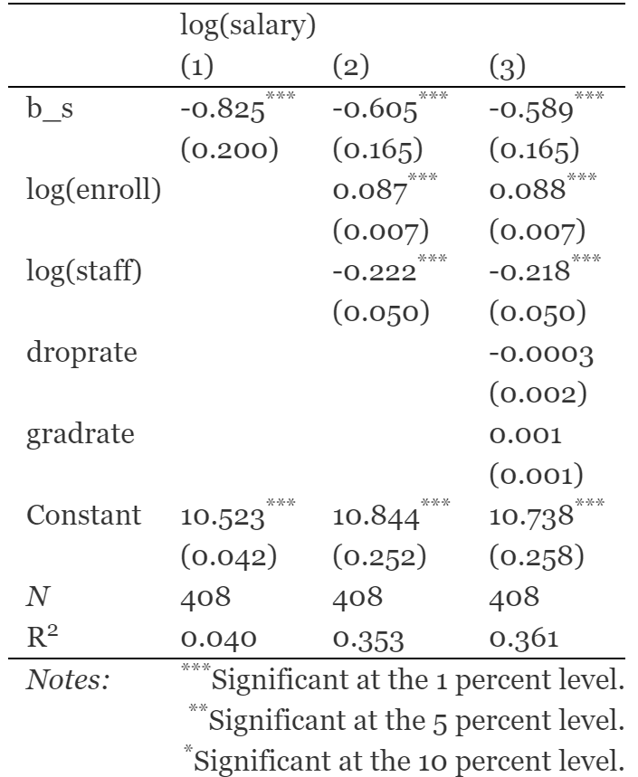

* AER publication style moves the intercept coefficient to the top.

stargazer(list(model1, model2, model3), type = "html",

keep.stat = c("n", "rsq"), **style = "aer"**, intercept.bottom = FALSE)

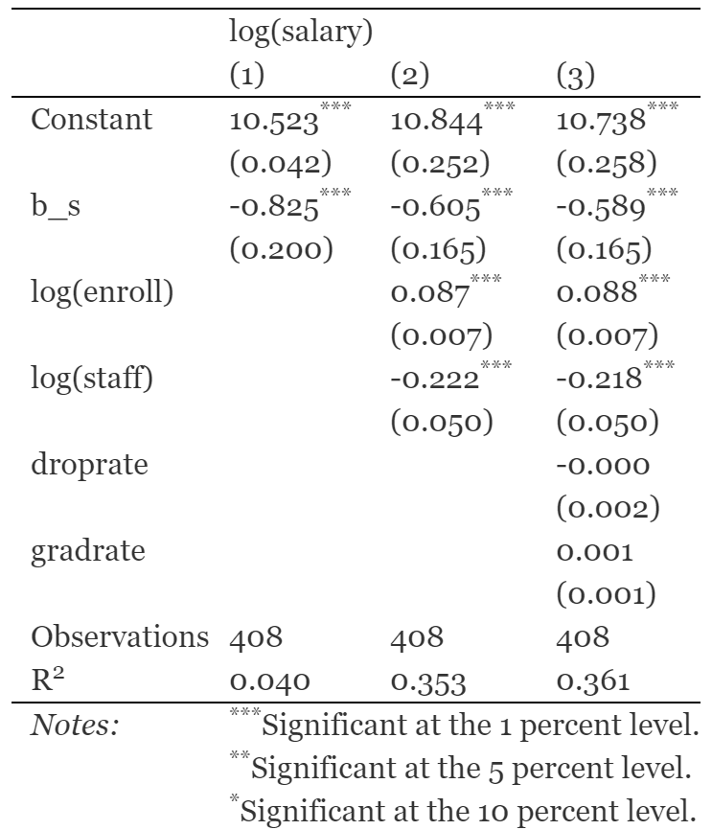

* Making changes, title, covariates names, changing caption and dependent variable label. Save the output in another file using out, changes the font size, removes the model number.

stargazer(list(model1, model2, model3), type = "html",

*title* = "These are awesome results!", align = TRUE,

*covariate.labels* = c("Benefits Salary Ratio", "Log(Enroll)",

"Log(Staff)", "Drop-Out Rate", "Graduation Rate"),

*column.labels* = c("Basic Model", "Non-linear",

"Updated"),

*dep.var.caption* = "A better caption",

*dep.var.labels* = "Log(Salary)", *out* = "reg_table.html")

